UNITED STATES

SECURITIES AND EXCHANGE COMMISSION
Washington, D.C. 20549

FORM 6-K

REPORT OF FOREIGN PRIVATE ISSUER

PURSUANT TO RULE 13a-16 OR 15d-16
OF THE SECURITIES EXCHANGE ACT OF 1934

Date of Report: November 17, 2021

Commission File No. 001-33811

NAVIOS MARITIME PARTNERS L.P.

7 Avenue de Grande Bretagne, Office 11B2

Monte Carlo, MC 98000 Monaco

(Address of Principal Executive Offices)

Indicate by check mark whether the registrant files or will file annual reports under cover of Form 20-F or Form 40-F:

☒ Form 20-F ☐ Form 40-F

Indicate by check mark if the registrant is submitting the Form 6-K in paper as permitted by Regulation S-T Rule 101(b)(1):

Yes ☐ No ☒

Indicate by check mark if the registrant is submitting the Form 6-K in paper as permitted by Regulation S-T Rule 101(b)(7):

Yes ☐ No ☒

Information Contained in this Report on Form 6-K

Attached hereto is a copy of the Notice of 2021 Annual Meeting of Limited Partners and Proxy Statement of Navios Maritime Partners L.P., dated November 17, 2021, for the 2021 annual meeting of Limited Partners to be held on Tuesday, December 21, 2021.


November 17, 2021

Dear Limited Partner,

We cordially invite you to attend our 2021 annual meeting of Limited Partners to be held at 11:30 a.m., local time, on Tuesday, December 21, 2021 at our offices at 7 Avenue de Grande Bretagne, Office 11B2, Monaco.

When you have finished reading the proxy statement, please promptly vote your interests by marking, signing, dating and returning the proxy card in the enclosed envelope. We encourage you to vote by proxy so that your interests will be represented and voted at the meeting, whether or not you can attend.

Sincerely,
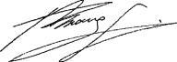

Angeliki Frangou

Chairman and Chief Executive Officer


NAVIOS MARITIME PARTNERS L.P.

NOTICE OF 2020 ANNUAL MEETING OF LIMITED PARTNERS

November 17, 2021

TIME:11:30 a.m., local time

DATE:Tuesday, December 21, 2021

PLACE:Offices of Navios Maritime Partners L.P., 7 Avenue de Grande Bretagne, Office 11B2, Monaco

PURPOSES:

- To elect two Class I directors to serve until the 2024 annual meeting of Limited Partners (“Proposal One”).

- To ratify the appointment of Ernst & Young (Hellas) Certified Auditors-Accountants S.A. as our independent registered public accounting firm for our current fiscal year ending December 31, 2021 (“Proposal Two”).

- To consider any other business that is properly presented at the meeting or any adjournment thereof.

WHO MAY VOTE:

The Board of Directors (the “Board of Directors”) of Navios Maritime Partners L.P. (the “Company,” “we,” “us” or “our”) has fixed the close of business on Monday, November 15, 2021 as the record date for the determination of the common unitholders, which we also refer to as the “Limited Partners,” entitled to receive notice and to vote at the annual meeting or any adjournment thereof. A list of common unitholders of record will be available at the meeting and, during the 10 days prior to the meeting, at the office of the Secretary at the above address.

IT IS IMPORTANT TO VOTE. WHETHER OR NOT YOU PLAN TO ATTEND THE ANNUAL MEETING, PLEASE COMPLETE, DATE, SIGN AND RETURN THE ENCLOSED PROXY. THE VOTE OF EVERY LIMITED PARTNER IS IMPORTANT AND YOUR COOPERATION IN RETURNING YOUR EXECUTED PROXY PROMPTLY WILL BE APPRECIATED. ANY SIGNED PROXY RETURNED AND NOT COMPLETED WILL BE VOTED IN FAVOR OF ALL THE PROPOSALS PRESENTED IN THE PROXY STATEMENT.

If you attend the annual meeting, you may revoke your proxy and vote in person.

BY ORDER OF THE BOARD OF DIRECTORS

Vasiliki Papaefthymiou

Secretary

NAVIOS MARITIME PARTNERS L.P.

7 AVENUE DE GRANDE BRETAGNE, OFFICE 11B2

MONTE CARLO, MC 98000 MONACO

PROXY STATEMENT FOR

NAVIOS MARITIME PARTNERS L.P.

2021 ANNUAL MEETING OF LIMITED PARTNERS

TO BE HELD ON TUESDAY, DECEMBER 21, 2021

GENERAL INFORMATION CONCERNING THE ANNUAL MEETING

Why Did You Send Me this Proxy Statement?

We sent you this proxy statement and the enclosed proxy card because our Board of Directors is soliciting your proxy to vote at the 2021 annual meeting of Limited Partners and any adjournments of the meeting to be held at 11:30 a.m., local time, on Tuesday, December 21, 2021, at our offices at 7 Avenue de Grande Bretagne, Office 11B2, Monaco. This proxy statement, along with the accompanying Notice of Annual Meeting of Limited Partners, summarizes the purposes of the meeting and the information you need to know to vote at the annual meeting.

On November 17, 2021, we began sending this proxy statement, the attached notice of annual meeting and the enclosed proxy card to all Limited Partners entitled to vote at the meeting. You can find a copy of our 2019 Annual Report on Form 20-F on the Internet through our website at www.navios-mlp.com or the U.S. Securities and Exchange Commission’s electronic data system called EDGAR at www.sec.gov.

Who Can Vote?

On November 15, 2021, we had outstanding 30,197,087 common units and 622,555 general partner units. Each Limited Partner of record at the close of business on November 15, 2021 is entitled to vote. One or more Limited Partners holding at least 33% of the total voting rights represented in person or by proxy at the annual meeting shall be a quorum for the purposes of the annual meeting. The common units represented by any proxy in the enclosed form will be voted in accordance with the instructions given on the proxy if the proxy is properly executed and is received by us prior to the close of voting at the annual meeting or any adjournment or postponement thereof. Any proxies returned without instructions will be voted FOR the proposals set forth on the Notice of Annual Meeting of Limited Partners.

The common units are listed on the New York Stock Exchange under the symbol “NMM.”

You do not need to attend the annual meeting to vote your common units. Common units represented by valid proxies, received in time for the meeting and not revoked prior to the meeting, will be voted at the meeting. A Limited Partner may revoke a proxy before the proxy is voted by delivering to our Secretary a signed statement of revocation or a duly executed proxy card bearing a later date. Any Limited Partner who has executed a proxy card but attends the meeting in person may revoke the proxy and vote at the meeting.

How Many Votes Do I Have?

Each common unit of Navios Maritime Partners L.P. that you own entitles you to one vote, subject to the provisions our limited partnership agreement.

How Do I Vote?

Whether you plan to attend the annual meeting or not, we urge you to vote by proxy. Voting by proxy will not affect your right to attend the annual meeting. If your common units are registered directly in your name through our transfer agent, Continental Stock Transfer & Trust Company, or you have physical certificates, you may vote:

- By mail. Complete and mail the enclosed proxy card in the enclosed postage prepaid envelope. Your proxy will be voted in accordance with your instructions. If you sign the proxy card but do not specify how you want your common units voted, they will be voted as recommended by our Board of Directors.

- In person at the meeting. If you attend the meeting, you may deliver your completed proxy card in person or you may vote by completing a ballot, which will be available at the meeting.

If your common units are held in “street name” (held in the name of a bank, broker or other nominee), you must provide the bank, broker or other nominee with instructions on how to vote your common units and can do so as follows:

- By mail. You will receive instructions from your bank, broker or other nominee explaining how to vote your common units.

- In person at the meeting. Contact the bank, broker or other nominee who holds your common units to obtain a broker’s proxy card and bring it with you to the meeting. You will not be able to vote at the meeting unless you have a proxy card from your broker.

“Street name” holders may vote by telephone or Internet if their bank, broker or other nominee makes those methods available, in which case the bank, broker or other nominee will enclose the instructions with the proxy materials. The telephone and Internet voting procedures are designed to authenticate Limited Partners’ identities, to allow Limited Partners to vote their common units, and to confirm that their instructions have been recorded properly.

How Does the Board of Directors Recommend That I Vote on the Proposals?

The board of directors recommends that you vote as follows:

- “FOR” the election of the nominees for Class I directors; and

- “FOR” ratification of the selection of independent registered public accounting firm for our current fiscal year ending December 31, 2021.

If any other matter is presented, the proxy card provides that your common units will be voted by the proxy holder listed on the proxy card in accordance with his or her best judgment. At the time this proxy statement was printed, we knew of no matters that needed to be acted on at the annual meeting, other than those discussed in this proxy statement.

May I Revoke My Proxy?

If you give us your proxy, you may revoke it at any time before the annual meeting. You may revoke your proxy in any one of the following ways:

- signing a new proxy card and submitting it as instructed above;

- notifying our Secretary in writing before the annual meeting that you have revoked your proxy; or

- attending the meeting in person and voting in person. Attending the meeting in person will not in and of itself revoke a previously submitted proxy unless you specifically request it.

What Vote is Required to Approve Each Proposal and How are Votes Counted?

Proposal 1: Elect the Class I Directors

The nominees for Class I directors who receive the most votes (also known as a “plurality” of the votes) will be elected. You may either vote FOR either or both of the nominees or WITHHOLD your vote from either or both of the nominees. Votes that are withheld will not be included in the vote tally for the election of the Class I directors. Brokerage firms do not have authority to vote customers’ unvoted common units held by the firms in street name for the election of directors. As a result, any common units not voted by a beneficial owner will be treated as a broker non-vote. Such broker non-votes will have no effect on the results of this vote.

Proposal 2: Ratify Selection of Independent Registered Public Accounting Firm

The affirmative vote of the majority of votes present or represented by proxy and entitled to vote at the annual meeting is required to ratify the selection of our independent registered public accounting firm. Abstentions will be treated as votes against this proposal. Brokerage firms have authority to vote customers’ unvoted

common units held by the firms in street name on this proposal. If a broker does not exercise this authority, such broker non-votes will have no effect on the results of this vote. We are not required to obtain the approval of our limited partners to select our independent accountants. However, if our limited partners do not ratify the selection of Ernst & Young (Hellas)

Certified Auditors-Accountants S.A. as our independent accountants for 2021, our Audit Committee of our Board of Directors will reconsider its selection.

What Constitutes a Quorum for the Meeting?

The presence, in person or by proxy, of the holders of at least 33% of our outstanding common units is necessary to constitute a quorum at the meeting. Votes of common unitholders of record who are present at the meeting in person or by proxy, withheld votes, abstentions, and broker non-votes are counted for purposes of determining whether a quorum exists.

PROPOSAL ONE

ELECTION OF CLASS I DIRECTORS

In accordance with the terms of our Fourth Amended and Restated Agreement of Limited Partnership, our Board of Directors consists of seven members; three of the members were appointed by our general partner at our first annual meeting following our initial public offering and four members were elected into three different classes. The appointed directors serve as directors for terms determined by our general partner or until his or her successor is duly appointed. The classified directors are elected by holders of our common units. At the 2018 annual meeting of Limited Partners, four classified directors were elected by holders of our common units for a term corresponding to their respective classes, consisting of two Class I directors elected for a term expiring at this annual meeting of Limited Partners, one Class II director elected for a term expiring at the 2022 annual meeting and one Class III director was elected for a term that expired in 2020, who was reelected at the 2020 annual meeting for a term expiring at the 2023 annual meeting.

The Board of Directors has nominated Kunihide Akizawa and Alexander Kalafatides, who presently serve as the Class I directors, to stand for election as Class I directors at this year’s annual meeting, for a three-year term expiring at our 2024 annual meeting.

Unless the proxy is marked to indicate that such authorization is expressly withheld, the persons named in the enclosed proxy intend to vote the common units authorized thereby FOR the election of the following nominees. It is expected that such nominees will be able to serve, but if before the election it develops that either or both of the nominees is unavailable, the persons named in the accompanying proxy will vote for the election of such substitute nominee(s) as the current Board of Directors may recommend.

Nominees for Election to the Company’s Board of Directors

Information concerning the nominee for election to our Board of Directors is set forth below:

Name |  | Age |  | Position
Kunihide Akizawa |  | 61 |  | Class I Director
Alexander Kalafatides |  | 57 |  | Class I Director

Kunihide Akizawa was appointed to our Board of Directors in July 2018. He has over 40 years of experience in shipping and logistics.

Mr. Akizawa started his shipping career in 1982 in Japan with Mitsui O.S.K. Lines, Ltd. He worked in the accounting department, the export department focusing on the Red Sea and Mediterranean areas, the bulk department, and a chartering manager of Skaarup Shipping International Corporation, which was a joint-venture company with Mitsui O.S.K. Lines, Ltd. In 1995, Mr. Akizawa joined ITOCHU Corporation in the logistics division. In 2011, he became President of MarineNet, a subsidiary of ITOCHU Corporation as well as five other major Japanese trading houses. In 2016, he was appointed as President of IMECS Co., Ltd, the ship-owing arm of ITOCHU and full subsidiary. In 2021, he joined Fleet Management Limited as Vice President Business Development. Mr. Akizawa is a graduate of Gakushuin University, Tokyo with a B.A. degree in Economics.

Alexander Kalafatides has been a member of our board of directors since 2019. Mr. Kalafatides has nearly 40 years of experience in general management and marketing. Mr. Kalafatides holds the position of global sales and marketing director of IUC International LLC, a designer and importer of consumer products, and he also serves as an adjunct professor in International Business at Drexel University. He has been involved in considerable turnarounds in various sectors including the marine sector, where he served as Partner and Vice President of CCSI, Inc., a company acting as the sales agent of the Chevron/Texaco joint venture. Following its successful turnaround, the company was acquired by the Chevron/Texaco group.

Mr. Kalafatides received his M.B.A. in marketing and international business from the New York University, his B.S.E. in computer engineering & science at the University of Pennsylvania and a Certificate of Director Education from Drexel University’s Gupta Governance Institute. Mr. Kalafatides serves as chairman of the Conflicts Committee and as a member of the Audit Committee, is an independent director.

Required vote. The directors will be elected by a plurality of the votes cast by holders of our common units (excluding common units owned by our general partner or its affiliates), meaning that the nominees for director receiving the highest number of common units voted “for” their election will be elected.

Effect of withheld votes and broker non-votes. Withheld votes will not affect the vote on Proposal One. Brokerage firms do not have authority to vote customers’ unvoted units held by the firms in street name for the election of directors. As a result, any units not voted by a beneficial owner will be treated as a broker non-vote. Such broker non-votes will have no effect on the results of this vote.

THE BOARD OF DIRECTORS UNANIMOUSLY RECOMMENDS A VOTE IN FAVOR OF THE PROPOSED CLASS I DIRECTORS. UNLESS REVOKED AS PROVIDED ABOVE, PROXIES RECEIVED BY MANAGEMENT WILL BE VOTED IN FAVOR OF THE PROPOSED DIRECTORS UNLESS A CONTRARY VOTE IS SPECIFIED.

PROPOSAL TWO

INDEPENDENT REGISTERED PUBLIC ACCOUNTING FIRM

The Board of Directors is submitting for approval the appointment of Ernst & Young (Hellas) Certified Auditors-Accountants S.A. as our independent registered public accounting firm for the fiscal year ending December 31, 2021. The Board of Directors proposes that holders of common units ratify this appointment. Ernst & Young (Hellas) Certified Auditors-Accountants S.A. audited our financial statements for the fiscal year ended December 31, 2020.

Ernst & Young (Hellas) Certified Auditors-Accountants S.A. has advised us that it does not have any direct or indirect financial interest in us, nor has it had any such interest in connection with us since our inception other than in its capacity as our independent auditors.

All services rendered by Ernst & Young (Hellas) Certified Auditors-Accountants S.A. are subject to review by our Audit Committee.

We are not required to obtain the approval of our Limited Partners to select our independent registered public accounting firm. In the event the holders of common units do not ratify the appointment of Ernst & Young (Hellas) Certified Auditors-Accountants S.A. as our independent registered public accounting firm, the Audit Committee will reconsider its appointment for future audits.

Required vote. Approval of Proposal Two will require the affirmative vote of a majority of votes present or represented by proxy and entitled to vote at the annual meeting.

Effect of abstentions and broker non-votes. Abstentions will be treated as votes against Proposal Two. Brokerage firms have authority to vote customers’ unvoted units held by the firms in street name on Proposal Two. If a broker does not exercise this authority, such broker non-votes will have no effect on the results of this vote.

THE BOARD OF DIRECTORS UNANIMOUSLY RECOMMENDS A VOTE TO RATIFY THE APPOINTMENT OF ERNST & YOUNG (HELLAS) CERTIFIED AUDITORS-ACCOUNTANTS S.A. AS OUR INDEPENDENT REGISTERED PUBLIC ACCOUNTING FIRM, AND PROXIES RECEIVED BY THE BOARD OF DIRECTORS WILL BE VOTED IN FAVOR OF SUCH RATIFICATION UNLESS A LIMITED PARTNER INDICATES OTHERWISE ON THE PROXY.

SOLICITATION

The cost of preparing and soliciting proxies will be borne by us. Solicitation on behalf of the Board of Directors will be made primarily by mail, but Limited Partners may be solicited by telephone, e-mail, other electronic means, or personal contact. Copies of materials for the annual meeting of Limited Partners will be supplied to brokers, dealers, banks and voting trustees, or their nominees, for the purpose of soliciting proxies from beneficial owners.

OTHER MATTERS

The Board of Directors is not aware of any other business that will be presented at the annual meeting. If any other business is properly brought before the annual meeting, it is intended that proxies in the accompanying form will be voted in accordance with the judgment of the person or persons named in the proxies.

BY ORDER OF THE BOARD OF DIRECTORS

Vasiliki Papaefthymiou

Secretary

November 17, 2021

[INSERT PROXY CARD]

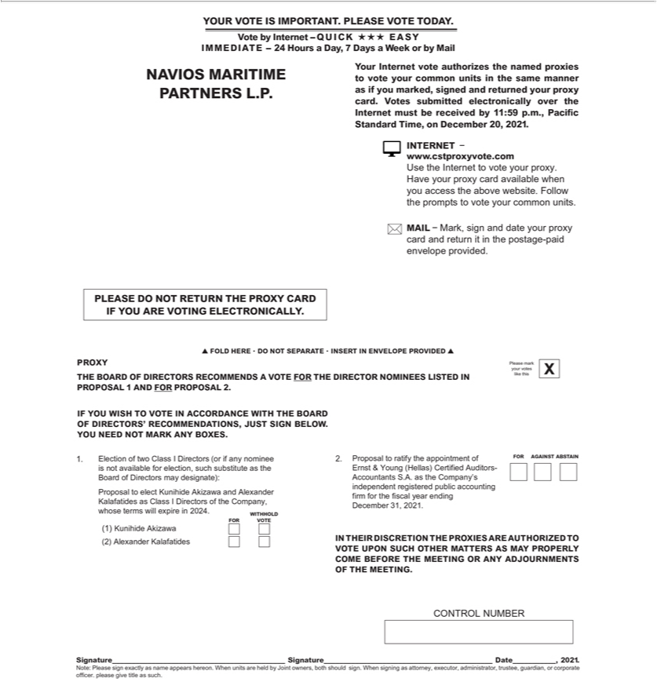

Signatures

Pursuant to the requirements of the Securities Exchange Act of 1934, as amended, the Registrant has duly caused this report to be signed on its behalf by the undersigned, thereunto duly authorized.

NAVIOS MARITIME PARTNERS L.P.

Date: November 17, 2021 By: /s/ Angeliki Frangou

Angeliki Frangou

Chairman and Chief Executive Officer

